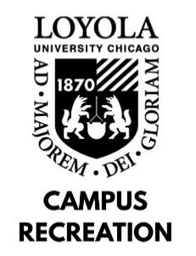

BUILDING MANAGER JOB DESCRIPTION

Departmental Student Employment Philosophy: As a student employee with Campus Recreation, you will play a vital role in providing recreational and social experiences to the university community. In combination with gaining experience in interpersonal communication and conflict resolution, employment with Campus Recreation will provide you with personal and professional development sessions, leadership opportunities, and comprehensive training programs designed to enhance your self-awareness, sense of community on campus, and critical problem-solving skills.

General Position Description: (insert job description): The Building Manager staff is responsible for supervision of the Halas Recreation Center and aids the Department of Campus Recreation in delivering an enjoyable experience for the Loyola Community. The Building Manager staff provides excellent customer service to members and guests at the Halas Recreation Center and assists the Program Coordinator in managing the Front Desk Staff.
Minimum Skills and Qualifications:
- Current full time Loyola University Chicago Student
- Ability to communicate using clear, concise, simple language
- Ability to maintain FA/CPR Certifications
- 1 Full Semester as a Campus Recreation Staff Member Campus Recreation

Preferred Skills and Qualifications:
- Previous experience in a service position preferred
- Federal Work Study preferred

Job Duties:
- Supervision of the Halas Recreation Center during open recreation and special events:
  - Coordination of opening/closing procedures, hourly counts, and all other daily operations.
  - Provide troubleshooting customer service support on all administrative activities, including memberships, locker/towel issues, etc.
  - Provide first response to injuries and emergencies.
  - Perform routine building inspections and report issues/emergencies as needed.
  - Supervise and assists on-site technical set-up and breakdown for events/programs.
  - Responsible for all building keys.
- Serve as a peer mentor to fellow Campus Recreation staff.
- Demonstrate working knowledge of Halas Recreation Center and Campus Recreation rules and regulations; ability and willingness to enforce rules and regulations.

Work Location and Environment:
- Building Manager staff will spend the majority of shifts moving around the building
- Must be capable of lifting up to 50 lbs for event set up

Learning Outcomes:
- Identify at least one way in which sense of community on campus has developed.
- Identify at least two ways in which communication skills have developed.
- Identify at least two ways in which problem-solving skills have developed.
- Identify at least one way in which self-awareness has developed.
- Identify at least one way in which leadership skills have developed.

